ASSIGNMENT 3

|  |  |
| --- | --- |
| Student Name | Vishnu Priya MK |
| Student Roll Number | 211519104185 |
| Maximum Marks | 10 Marks |

Question 1&2:

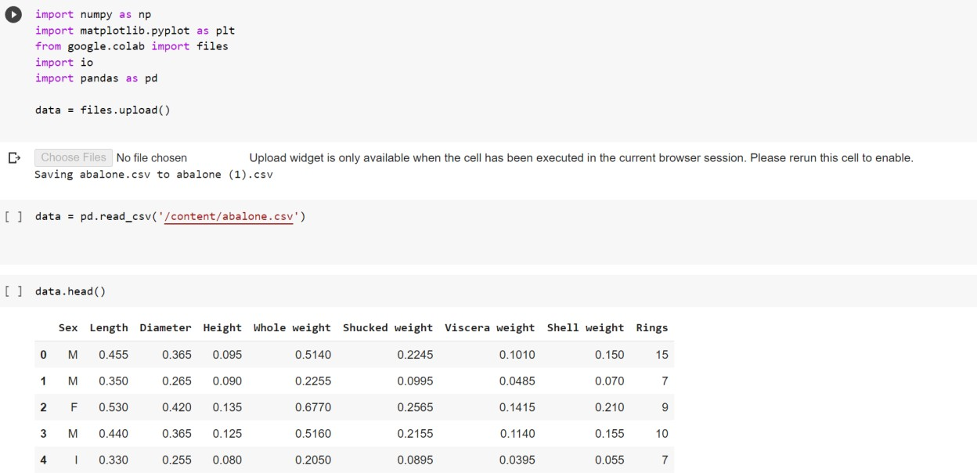

# Question 3:

Perform Below Visualizations.

# Univariate Analysis

* Bi-Variate Analysis

# Multivariate Analysis

Univariate Analysis

import matplotlib.pyplot as plt import seaborn as sns data.dtypes

plt.scatter(data.index,data['Height']) plt.show()

# Bi-Variate Analysis

import seaborn as sns sns.boxplot(x='Sex',y='Height',data=data) plt.show()

# Multi-Variate Analysis

import seaborn as sns sns.pairplot(data,hue="Rings",height=3) plt.show()

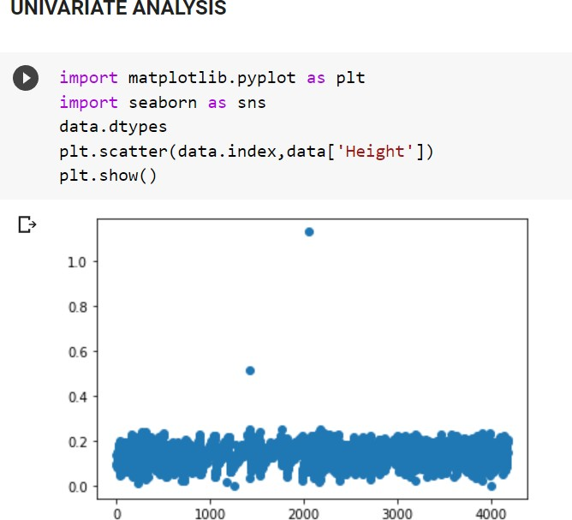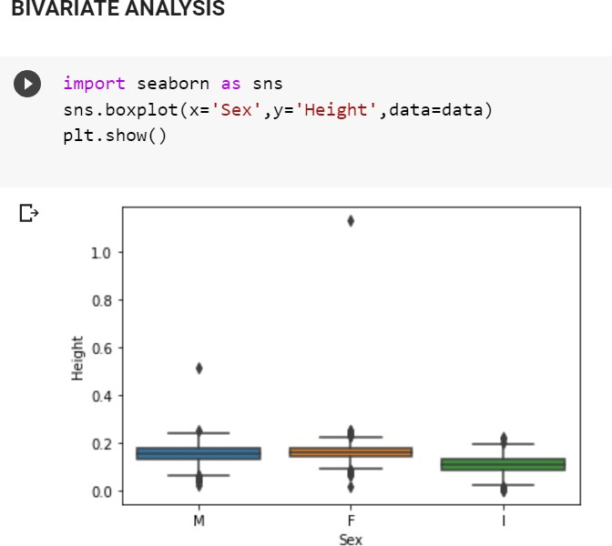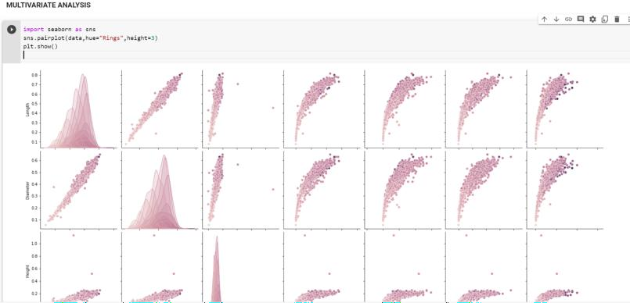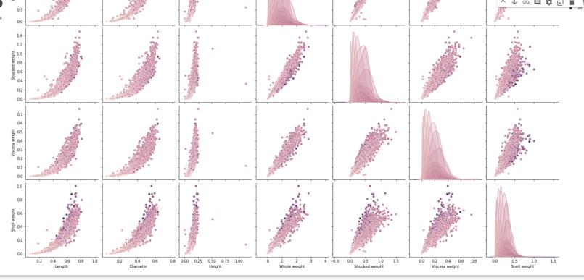

# Question 4. Perform descriptive statistics on the dataset.

import pandas as pd

import numpy as np

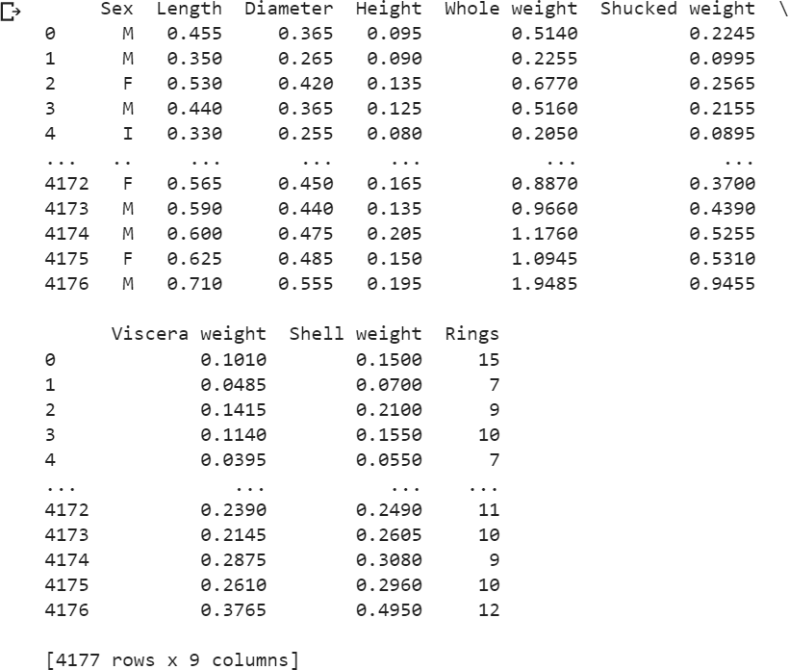df = pd.DataFrame(data) print (df) df.describe() df.count()

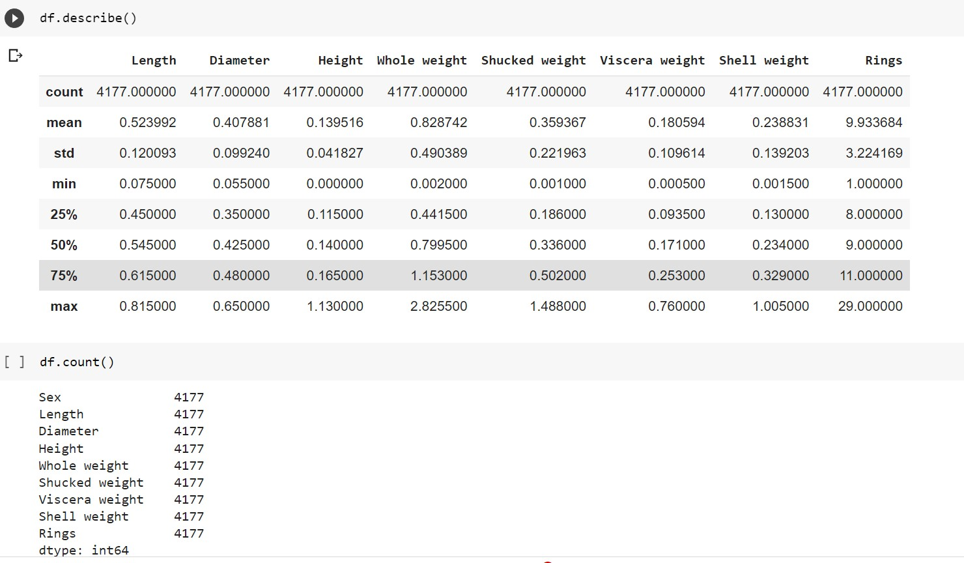

# Question 5. Check for Missing values and deal with them.

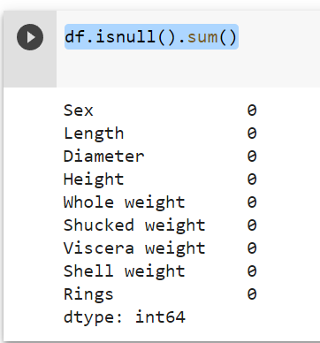df.isnull().sum()

# Question 6 Find the outliers and replace them outliers

import seaborn as sns sns.boxplot(x='Height', data=data)

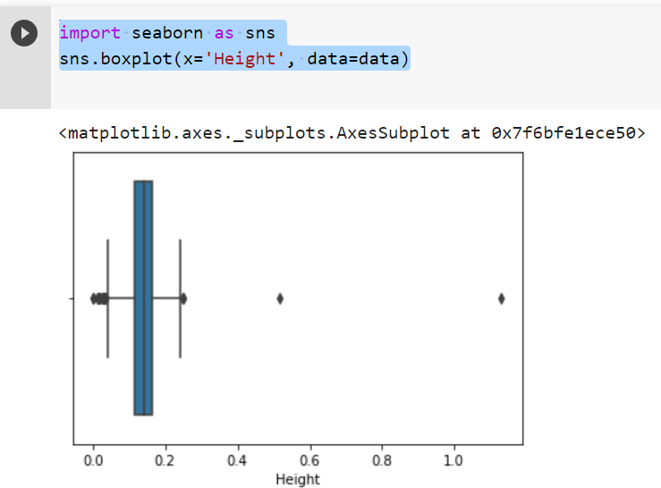

# Question 7. Check for Categorical columns and perform encoding.

df = pd.DataFrame(data) import pandas as pd x=df.iloc[:,3:13].values y=df.iloc[:,13:14].values x.shape

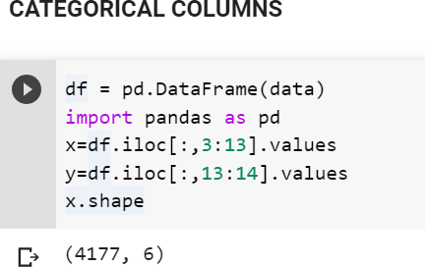

# Question 8 Split the data into dependent and independent variables.

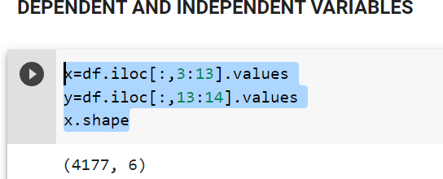x=df.iloc[:,3:13].values y=df.iloc[:,13:14].values x.shape

# Question 9. Scale the independent variables

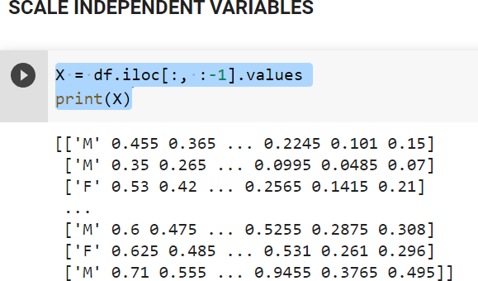X = df.iloc[:, :-1].values print(X)

# Question 10. Split the data into training and testing

from sklearn.model_selection import train_test_split x_train,x_test,y_train,y_test=train_test_split(x,y,test_size=0.2,random_st ate=0)

x_train.shape x_test.shape x_train.shape

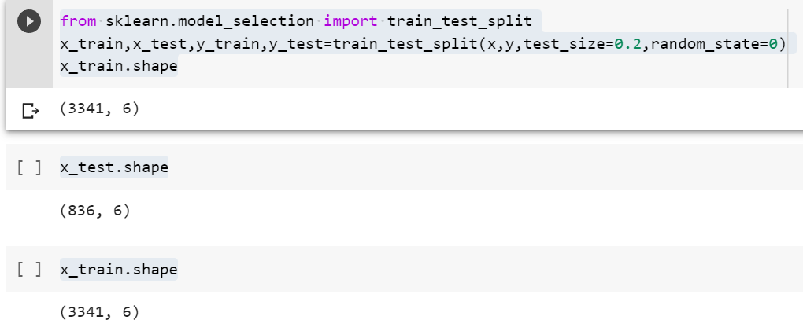

# Question 11. Build the Model

my_dict=pd.read_csv("/content/abalone.csv") df = pd.DataFrame(my_dict)

print(df)

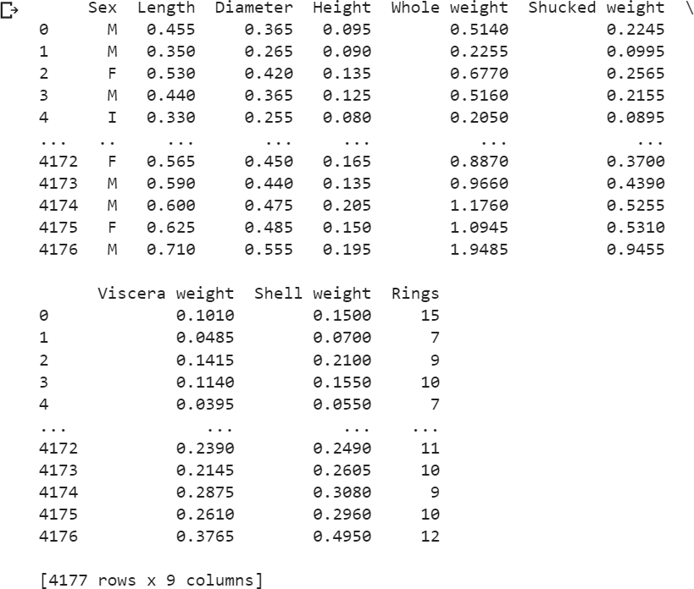

import csv

with open ("/content/abalone.csv") as csv_file: csv_reader = csv.reader(csv_file)

df = pd.DataFrame([csv_reader], index = None) for val in list(df[1]):

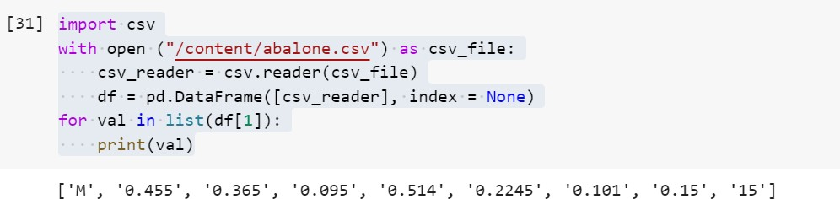print(val)

# Question 12 & 13 Train and Test the Model

from sklearn.model_selection import train_test_split

train, test = train_test_split(df, test_size=0.2) print(train)

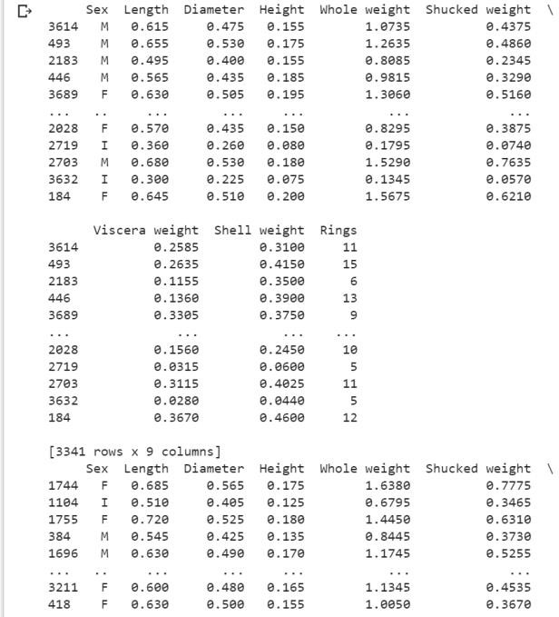print(test)

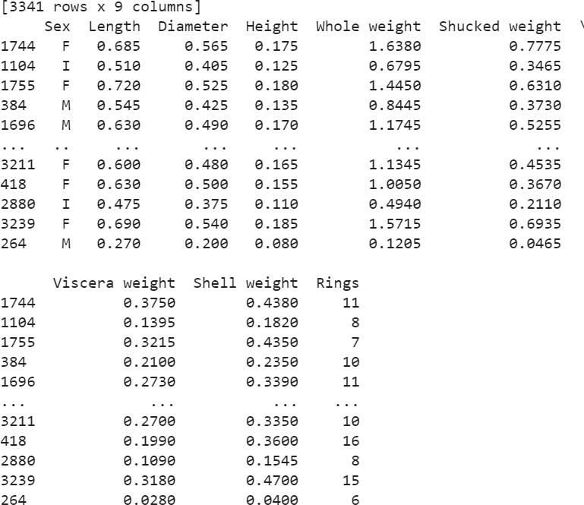

# Question 14. Measure the performance using Metrics.

pd.crosstab(Y_test,y_predict) print(classification_report(Y_test,y_predict))